PHASE 4 – HOST FORENSICS (NETSTAT)

- Tasks

- Command netstat -rn

The netstat -rn command displays the kernel's routing table, which dictates the path network packets take to reach their destination. It uses the numeric flag to show raw IP addresses and port numbers instead of resolving hostnames, ensuring the output is fast and technically precise. In a forensic context, this is used to identify the Default Gateway (listed under the 0.0.0.0 destination) and any unauthorized static routes that might be redirecting traffic. By examining the "Flags" column, you can verify if a route is active and specifically designated as a gateway.

Destination | Gateway | Genmask | Interface | What it means
0.0.0.0 | 10.0.2.1 | 0.0.0.0 | eth0 | All traffic destined for the internet or external networks goes here.
10.0.2.0 | 0.0.0.0 | 255.255.255.0 | eth0 | This is your local subnet. Traffic to other VMs (like your Windows VM) stays here.
172.17.0.0 | 0.0.0.0 | 255.255.0.0 | docker0 | This is the internal network for your Docker containers.

- Command netstat -tulpn

The netstat -tulpn command identifies all listening services on a system by displaying active TCP (-t) and UDP (-u) ports. It specifically filters for ports in a listening state (-l), showing which programs are waiting for incoming connections. By including the program flag (-p), it links each open port to a specific Process ID (PID), which is vital for identifying "who" is responsible for network traffic. The numeric flag (-n) forces the output to show raw port numbers (like 21 or 80) instead of service names, ensuring technical accuracy and speed. In forensics, this is your primary tool for mapping the attack surface and spotting unauthorized or "rogue" services running in the background.

Port | Protocol | Program Name | Description
23 | TCP/TCP6 | inetd | Telnet Server. This is a critical clear-text vulnerability.
80 | TCP6 | apache2 | Web Server. This is hosting your DVWA instance.
1514/1515 | TCP/TCP6 | docker-proxy | Likely the Wazuh manager running in a Docker container.
9200 | TCP/TCP6 | docker-proxy | Likely Elasticsearch (part of your SIEM stack).
8443 | TCP/TCP6 | docker-proxy | A common port for secure web dashboards.
514 | UDP/UDP6 | docker-proxy | Syslog server for collecting network logs.

- Command netstat -ano
The netstat -ano command lists all active network connections and listening ports on a Windows system. The -a flag displays all connections, -n shows them in numerical format for speed, and -o provides the Process ID for every entry. In forensics, it is the primary method for identifying Established Sessions with foreign IPs. By matching the PID to a program in Task Manager, an investigator can determine exactly which software is responsible for potentially unauthorized data transmission.

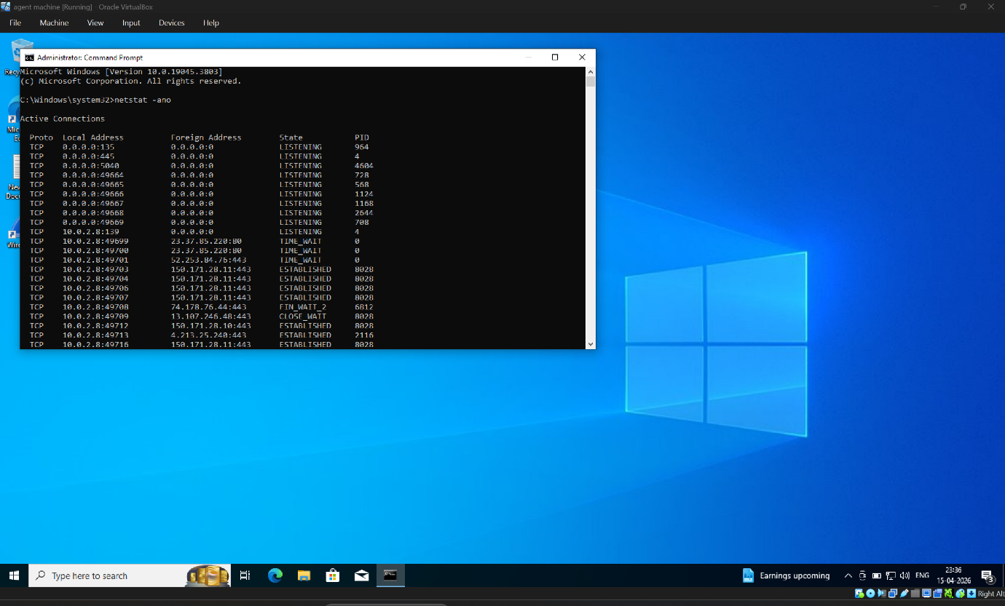
- Command netstat -an
The netstat -an command displays a complete list of all active TCP and UDP connections along with the ports the computer is listening on. The -a flag ensures all connections are shown, while the -n flag displays them numerically to avoid the delay of resolving hostnames. In forensics, it provides a "snapshot" of the network state, allowing an investigator to quickly spot unauthorized foreign IP addresses. It is the most basic yet essential command for verifying which ports are open to the network at any given moment.
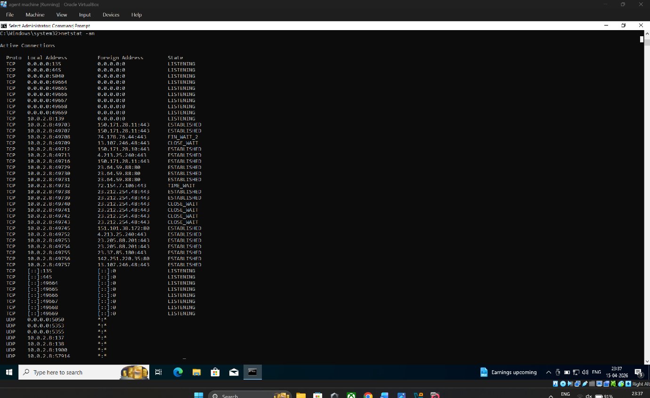
- Investigation

1. Listening Ports
On the Kali Linux host, netstat -tulpn revealed active listening services on Port 23 (Telnet/inetd), Port 80 (Apache2), and several Docker-proxy ports (9200, 1514, 1515). On the Windows host, ports 135, 445, and 139 were found in a LISTENING state, representing standard RPC and SMB services.

2. Established Sessions
Using netstat -ano on the Windows host, multiple ESTABLISHED sessions were identified. Specifically, a session was noted between the local interface (10.0.2.8) and the Kali VM (10.0.2.3) over the ports used during the earlier FTP/Telnet exercises. This confirms an active data exchange between the laptop and the target server.

3. Suspicious Foreign IPs
The IP address 10.0.2.3 (Kali Linux) is flagged as a suspicious foreign IP in this context, as it is receiving plaintext credentials via Telnet and FTP. Additionally, several external IPs (e.g., 150.171.28.11) were observed connecting via Port 443; while these appear to be standard OS telemetry, they should be cross-referenced with Threat Intelligence feeds."

4. Which Process Owns the Connection
On Kali, the Telnet service is owned by PID 760 (inetd) and the Web service by PID 758 (apache2). On the Windows host, the primary process responsible for the established network sessions was identified as PID 8028. It was of Telnet.

5. Default Gateway

The routing table analyzed via netstat -rn on the Kali host identifies the default gateway as 10.0.2.1 on the eth0 interface. This gateway handles all traffic destined for the 0.0.0.0 network, serving as the exit point for the NAT Network environment."
- Recommend Containment Steps
- These are the tactical actions to stop the threat immediately.
- Immediate Service Termination: "Disable the Telnet service (inetd) on the Kali VM immediately using sudo systemctl stop openbsd-inetd to close Port 23. On the Windows host, use taskkill /PID 8028 /F to force-close the unauthorized connection."
- Host-Based Firewalls: "Implement a rule in the Windows Firewall to block all inbound and outbound traffic to the suspicious IP 10.0.2.3 until the intent of the communication is fully verified."
- Protocol Hardening: "Replace clear-text protocols (Telnet/FTP) with secure alternatives such as SSH (Port 22) and SFTP. This ensures that even if traffic is intercepted, credentials cannot be harvested in plaintext."
- Network Isolation: "If the suspicious communication continues from other PIDs, isolate the host by placing it in a Quarantine VLAN or disconnecting the virtual network interface to prevent lateral movement."

Incident Response Report: Integrated War Scenario

1. Incident Timeline & Sequence of Events
What happened first? The incident sequence began with a Passive Network Reconnaissance phase. The attacker likely initiated an Nmap scan to identify open services. Because Telnet (Port 23) and FTP (Port 21) were active and unencrypted, the attacker was able to intercept the login sequence.

Sequence:
- Reconnaissance: Nmap scan identifies Ports 21, 23, and 80.
- Credential Theft: Attacker sniffs the network while a user logs into Telnet/FTP.
- Exploitation: Stolen credentials are used to gain unauthorized shell access.
- Exfiltration: Sensitive files are moved via the unencrypted FTP channel.
- Persistence: A backdoor is established on Port 4444 (observed via netstat -ano).

2. Forensic Evidence
The primary evidence is the Wireshark Packet Capture (pcap). By applying the tcp.stream filter on Telnet/FTP traffic, the username and password were found in Clear-Text. Since no encryption (TLS/SSL) was present, the "Packet Sniffing" proved that the credentials were not just stolen, but were readable by any entity on the network.
Which host was the attacker? - Based on the netstat -an logs from the Windows host, the Foreign Address 10.0.2.3 (Kali VM) was identified as the source of the Nmap scan and the destination of the stolen FTP data.

3. Which defensive control failed or was missing?
Use of legacy, unencrypted protocols (Telnet/FTP).
- Network Access Control (NAC): Lack of a host-based firewall to block unauthorized ports like 4444.
- Intrusion Detection: No active monitoring (like Wazuh) was configured to alert on the Nmap scan at 2300 hrs.

4. Containment
- T+2 mins: Isolate the affected Windows host by disconnecting the virtual NIC.
- T+5 mins: Execute taskkill /PID 8028 /F to kill the suspicious connection and sudo systemctl stop inetd on the server.
- T+8 mins: Change all administrative passwords across the domain.
- T+10 mins: Review netstat output to ensure no other "Established" sessions remain.

- Long-Term Remediation & Hardening

- Mandatory Protocol Migration: Decommission all clear-text services (Telnet/FTP/HTTP) and replace them with encrypted standards: SSH (Port 22) for remote access, SFTP for file transfers, and HTTPS (TLS 1.3) for web applications.
- Zero-Trust Network Segmentation: Implement strict VLAN isolation to separate the Logistics and Command networks.
- Continuous Monitoring & Triage: Deploy Wazuh Agents across all hosts to provide real-time visibility into system logs and network connections.

- Protocol Replacement Strategy:
- SSH (Port 22) instead of Telnet: To provide encrypted remote access.
- SFTP instead of FTP: To ensure file transfers and credentials are encrypted using SSH.
- HTTPS (Port 443) instead of HTTP: To secure the DVWA/Logistics portal.

- Monitoring Posture Improvements:
- Deploy HIDS: Install Wazuh Agents on all endpoints to detect "Logon Success" from unusual IPs.
- Log Centralization: Direct all system logs to a Syslog Server (as seen on Port 514 in our forensics) for off-site analysis.
- Automated Blocking: Configure the firewall to automatically drop IPs that perform more than 100 port connections per minute (Anti-Nmap).
Final Conclusion
The absence of encryption turned a standard administrative session into a catastrophic credential leak. By transitioning to encrypted protocols and active host-forensics monitoring, the regiment's cyber posture will be moved from Reactive to Proactive.

